**iNeuron Assignment(09/10/2022) Sachin Kothari**

**Class Assignment**

1. **Install all the dependencies for making centOS full screen**

Ans:- Make display 128 in resolution of video in virtual box

Open Terminal and execute below commands

Sudo yum -y install gcc

Sudo yum install make perl

Sudo yum -y install kernel-devel-$(uname -r)

Sudo yum install elfutils-libelf-devel

After this is done, we need to run the guest and restart and then full screen mode is enabled

1. **Please update you CentOs machine**

Ans:- sudo yum update

**Assignment Questions**

1. **What happens when you login a non-existent users or username?**

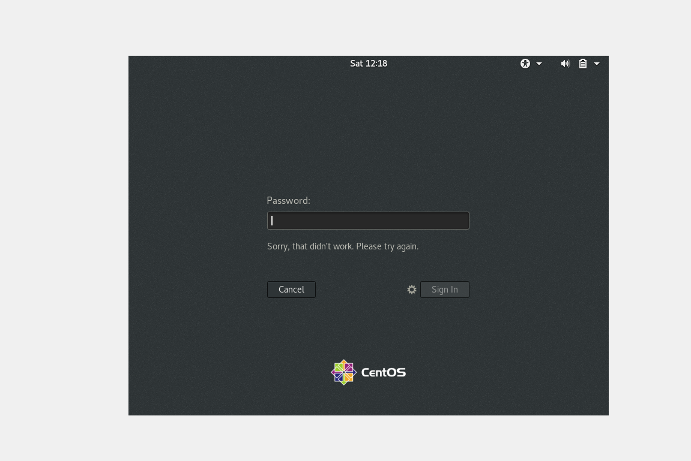

Ans: - When I tried to login as a non-existent user, It asked me if your username is not listed, type in manually the username and password and I got the above error message. So when I login as a non-existent user, Linux doesn’t allow to go inside the system.

1. **Login into your account and then change password?**
   1. 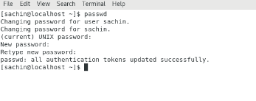Change your password into ***IneuR0n#42*** and hit the **Enter** key

Ans:- When I changed the password to IneuROn#42 It gave me above message in the screenshot and I was successfully able to change the password

* 1. Try again to change password but use like password ***1234*** or ***abcd***

Ans:- It gave me error message with password is shorter than 8 characters.

* 1. Try again to change password but now don’t use any password just hit **Enter** key

Ans:- It gave me a error message with no password supplied.

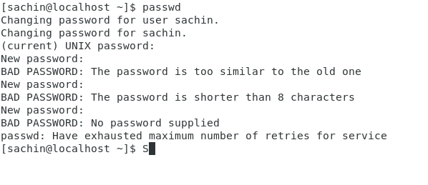

1. **Working with Directories**
   1. Enter the command **cd /** and then **ls** and then hit **Enter** key

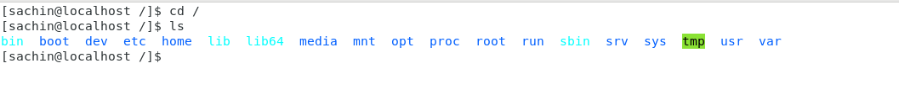Ans:- When I do **cd /** it moves to root directory and ls gives the list of files present in root directory

* 1. Enter the command now **cd /home** and then hit Enter key

Ans :- When we do cd /home, it goes to users working home directory and ls gives the list of users present.

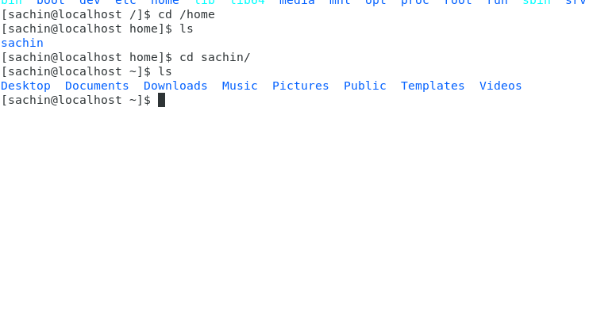

* 1. Enter **cd ..** and hit **Enter** key [ *Note: here we have space after cd then use double dot*]

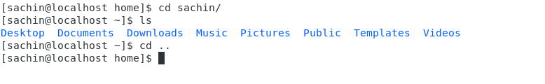Ans:- When we hit cd .., we go to the previous directory from where we are present

* 1. Now enter **cd /var/www/html** and then type **cd** and hit **Enter** key

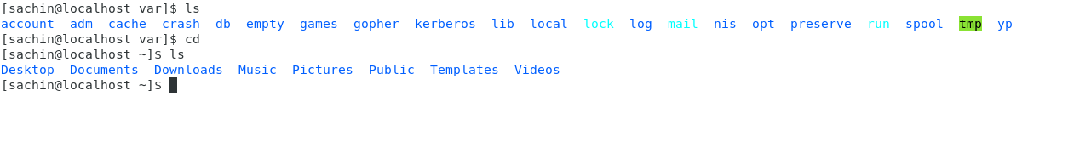Ans:- I dint have /var/www/html so I went to /var folder and did cd, It went back to home directory.

* 1. Now type **cd /root** and then hit **Enter** key

When I hit cd /root. It throws me a error with “**Permission Denied”**

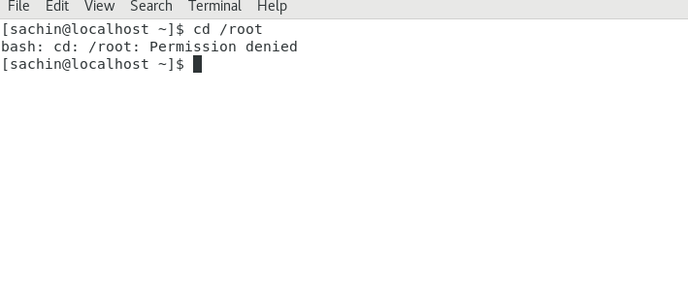

1. Working with File Listing
   1. Go to **cd /etc** and type **ls**

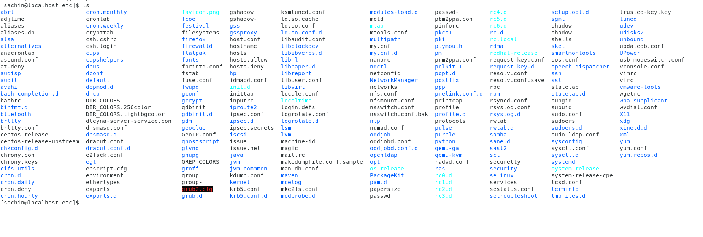In this path we have the linux configuration files, this /etc is inside root path. To access root we must be a root user and /etc can be accessed with any user.

* 1. Then type **ls -al** and hit **Enter** key

When we type ls -al, it gives us the permission each file posses and who is the user for that particular file, and date when it was created.

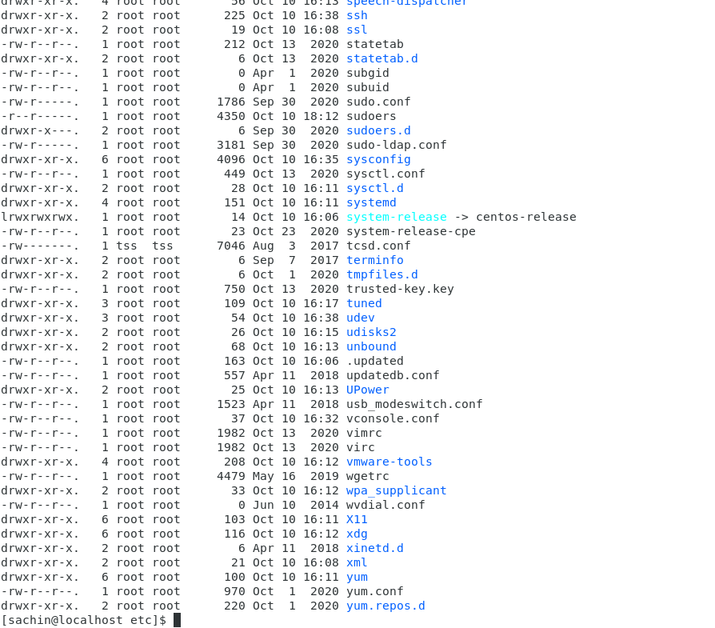

* 1. Then use **ls -i** and hit Enter key

It lists inode(index) number of the file

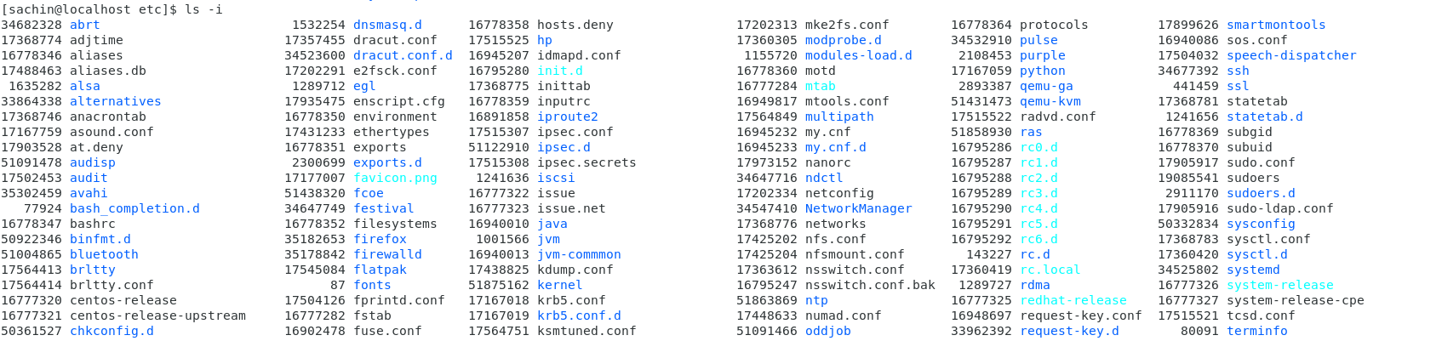

* 1. Then use **ls –help** and see other options about **ls** command

It shows us the subcommands which can be used with ls command

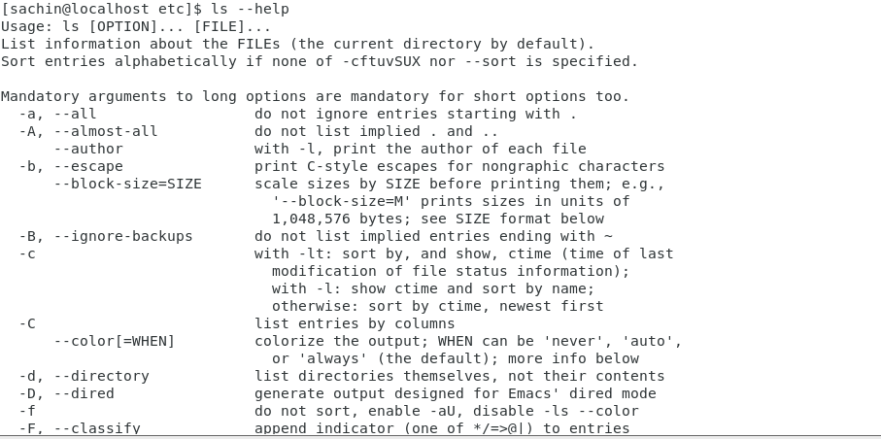

1. Know where you are and where you working

**Open terminal after restart the linux ,Check which location you working, type pwd and take screenshot**

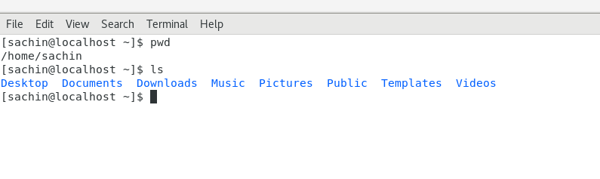When we restart the linux and open terminal, I come to /home/sachin path which is the users path in home directory

**Now use cd /var and hit Enter key**

/var is a standard subdirectory of the root directory in Linux and other Unix-like operating systems that contains files to which the system writes data during the course of its operation.

